CS

CS200T SW User Manual

**Version : 4.0.0**

**Release Date: 2019/2/1**

**Issued by Steven Chiang**

*Content*

Automated Signage Solution 1

Automated Signage Solution 3

■ Device Setting Diagram 3

➢ A. Projector + CS200T 3

➢ B. Projector + Graphic Card 4

■ Projector Position 4

■ Software Installation 6

➢ A. Manual by Wizard / Device request – Projector + CS200T 6

➢ B. Manual by Wizard / Device request – Projector + Graphic Card 11

➢ C. Auto Wizard / Device request – Projector + CS200T 16

Fine Tune 18

Advanced Fine Tune 21

# Automated Signage Solution

Automated Signage Solution supports both CS200T and Graphic Card.

Please refer to the instruction according to user’s device setting.

* Device Setting Diagram

### A. Projector + CS200T

**ZH420UST**

**ZH420UST**

**CS200T**



**HDBaseT Port1**

**HDBaseT Port2**

**LAN Port**

**HDMI 2.0**

**Input**

**HDMI 2.0 Cable**

**Cat5 Cable**

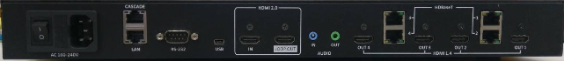

### B. Projector + Graphic Card

【Note】Graphic card setting: Adjust multiple display settings to “Duplicate mode”.

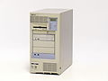

**ZH420UST**

**ZH420UST**

**Ethernet Hub**

**LAN Port**

**LAN Port**

**LAN Port**

**HDMI 2.0**

**Input**

**HDMI 2.0 Cable**

**Cat5 Cable**

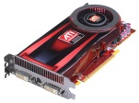

**HDMI 2.0**

**Input**

* Projector Position

The effective range of overlap area is between 10% and 50%. Check the rough overlap area by test pattern “H/V Mark” when setting projectors.

1. Open the H/V Mark by OSD

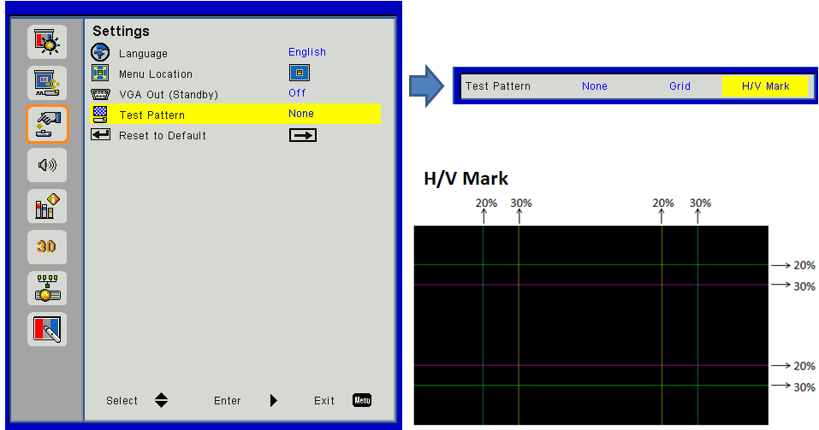

1. Check the side of adjacent projectors in the effective overlap area.

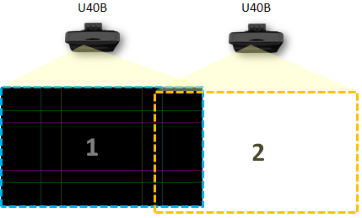

* Software Installation

Install the software on Windows OS control device.

### A. Manual by Wizard / Device request – Projector + CS200T

1. **Step 1: Select “File / New Project (Manual)”.**

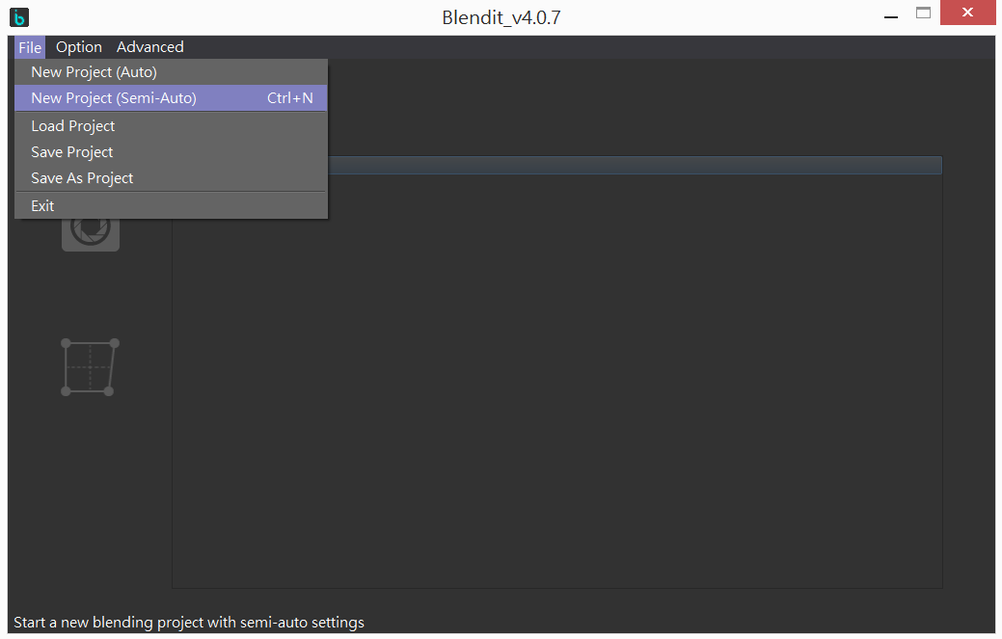

1. **Step 2: Select Device**

Select devices according to user’s requirement.

【Note】Click Device Type to correspond the device name on wizard with projectors.

When user clicks projector - Projector being selected shows “Pink” pattern.

When user clicks Box – All projectors show “Yellow” pattern.

【Note】Click Device Name can rename device.

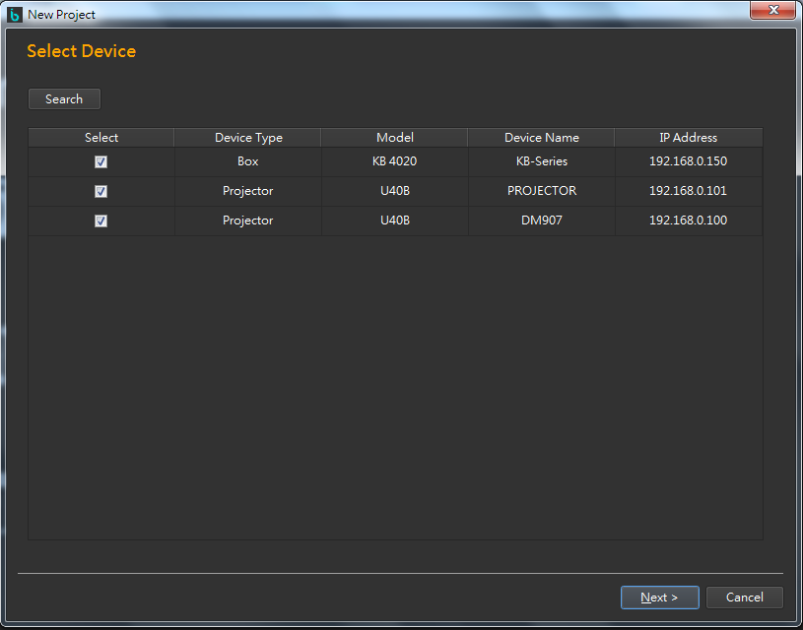

1. **Step 3: Layout Setting**

Blending Layout Setting

Example: Application for 2 projectors. Layout Row=1, Column=2

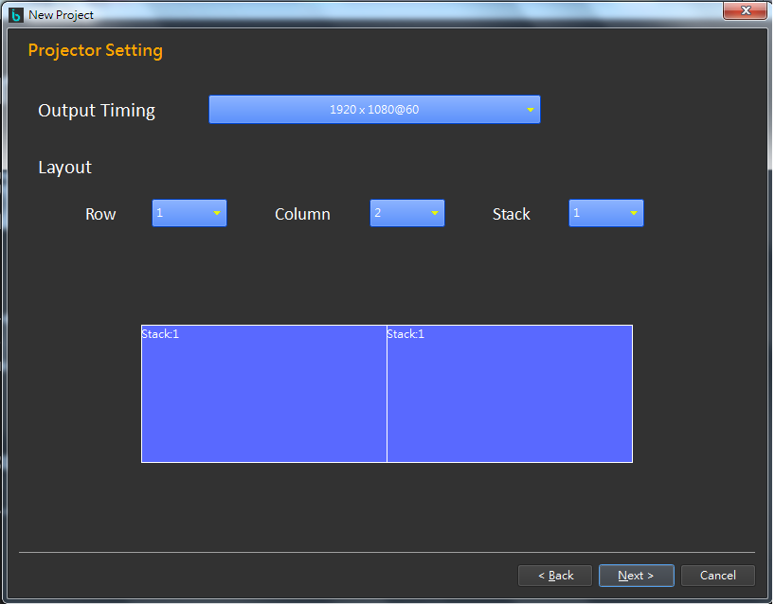

1. **Step 4: Auto Search Camera Position**
2. Select the screen on setting interface according to the actual position of blue projection.

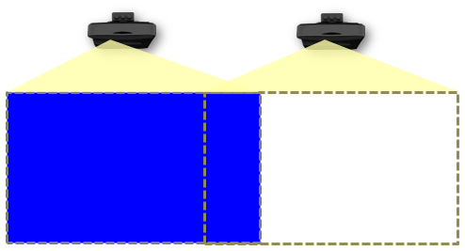 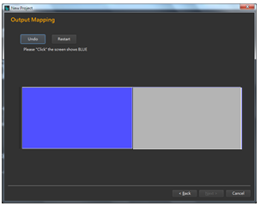

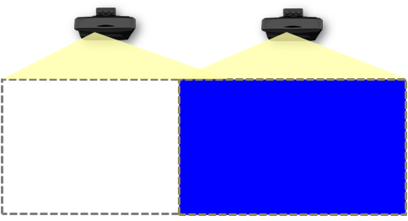 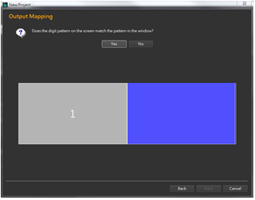

1. Check does the number of digit pattern of actual projection match the pattern on the wizard.

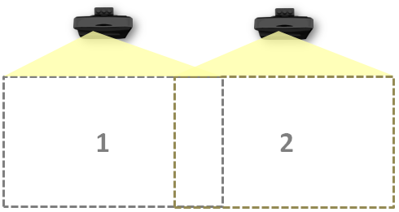 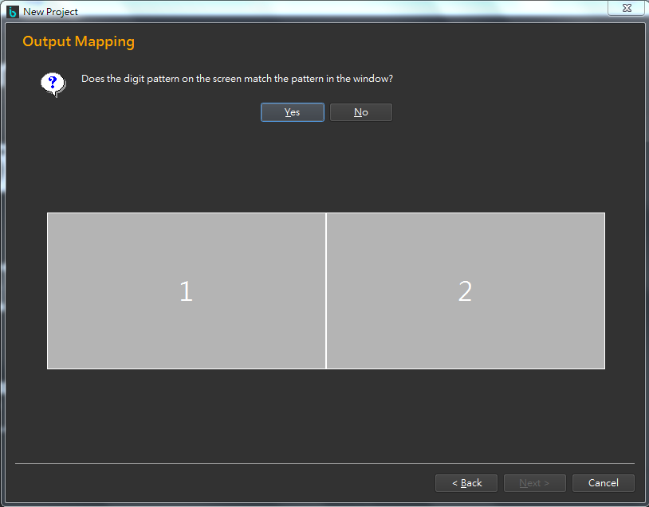

1. **Step 5: Overlap Setting**
2. Adjust the control bar to set overlap area. (The range of overlap area is from 10% to 50%). Determine the overlap area on projection display when adjusting.
3. Click “Finish” button to finish all the setting.

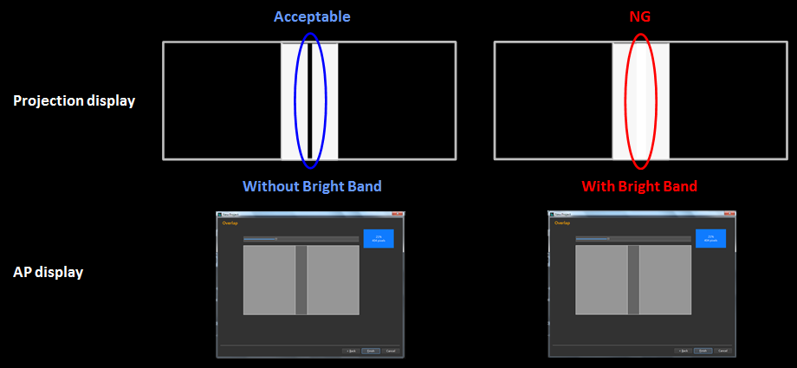

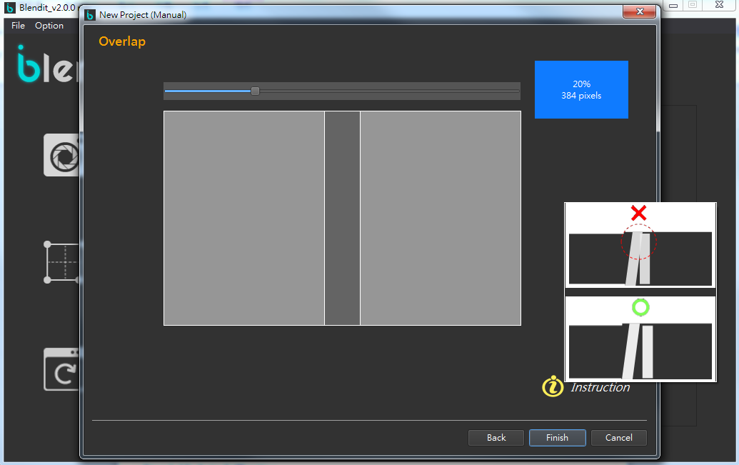

**10%**

**50%**

1. **Step 6: Pattern Area Settings**
2. (1) Check if all the dots are shown inside the frame.
3. 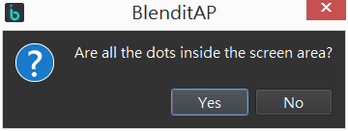



1. 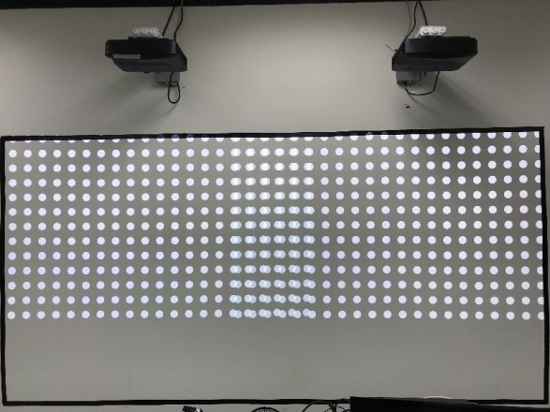 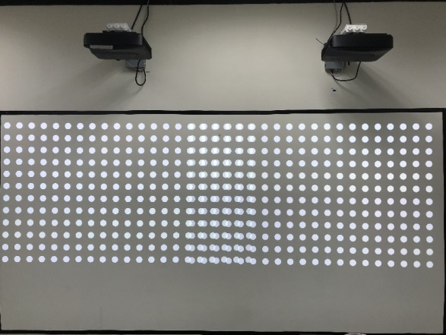

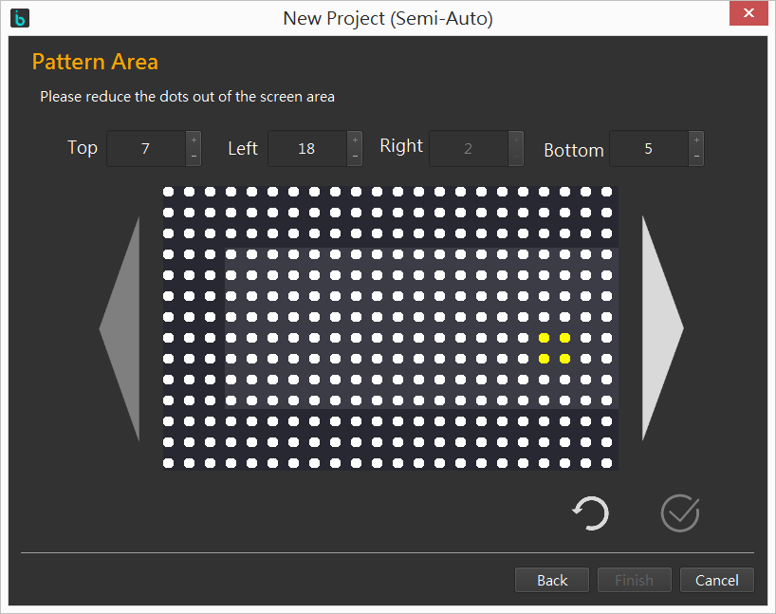

Editable area. Use the spin boxes to add or remove the dots.

1. **Step 7: Auto Calibration**
2. Click “Auto Calibration” button to finish image blending automatically.

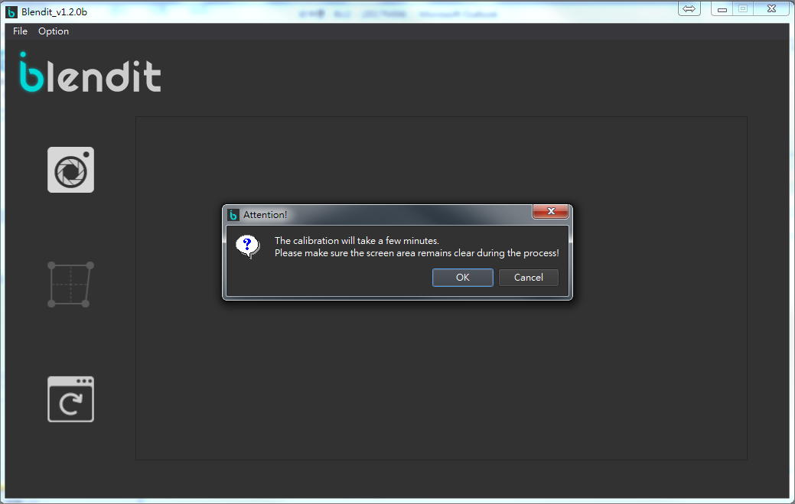

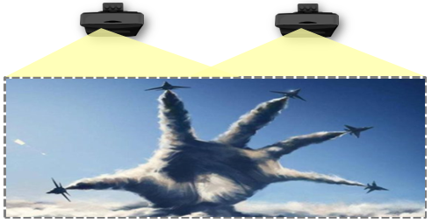

### B. Manual by Wizard / Device request – Projector + Graphic Card

1. **Step 1: Select “File / New Project (Manual)”.**

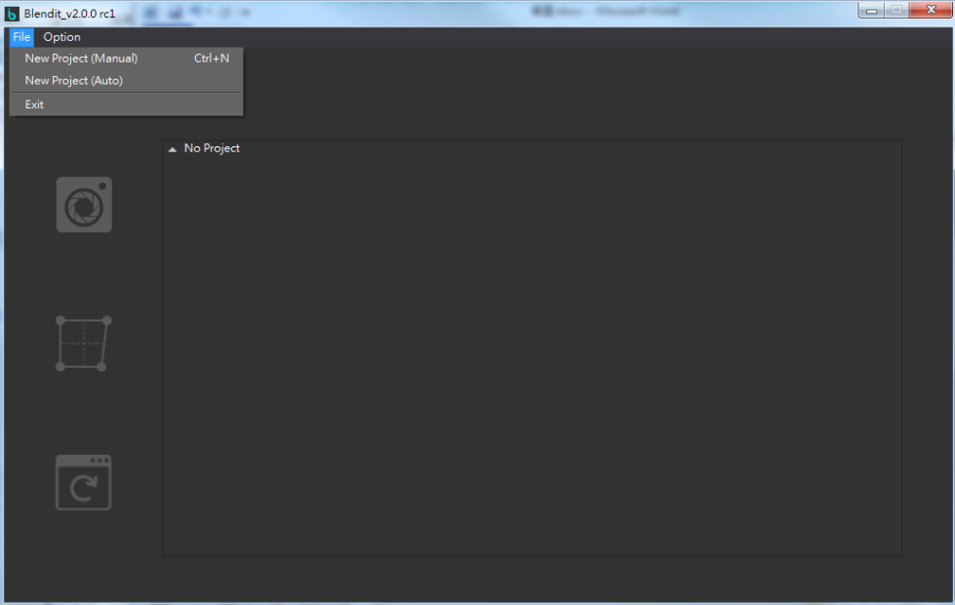

1. **Step 2: Select Device**

Select devices according to user’s requirement.

【Note】Click Device Type to correspond the device name on wizard with projectors.

When user clicks projector - Projector being selected shows “Pink” pattern.

【Note】Click Device Name can rename device.

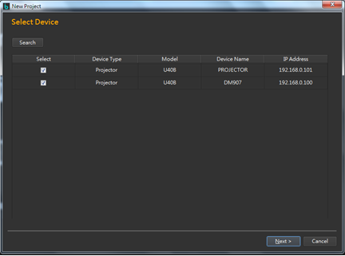

1. **Step 3: Layout Setting**

Blending Layout Setting

Example: Application for 2 projectors. Layout Row=1, Column=2



1. **Step 4: Auto Search Camera Position**

Select the screen on setting interface according to the actual position of blue projection

 

 

1. Click “Show Order” to confirm the camera positions on projection display.

【Note】Press any key or wait for 3 seconds to go back to AP display.

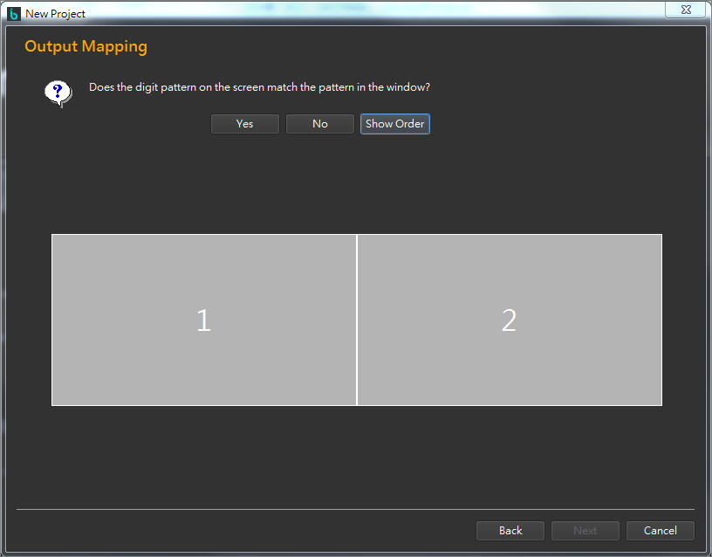 

1. **Step 5: Overlap Setting**
2. (1) Adjust the control bar to set overlap area. (The range of overlap area is from 10% to 50%).
3. (2) Click “Show Overlap”, users can adjust overlap area by key  and determine the overlap

area on projection display when adjusting.

【Note】AP display is be hided under this mode.

1. (3) Click “Finish” to finish all the setting.

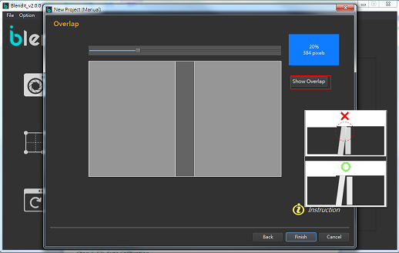

**50%**

**10%**

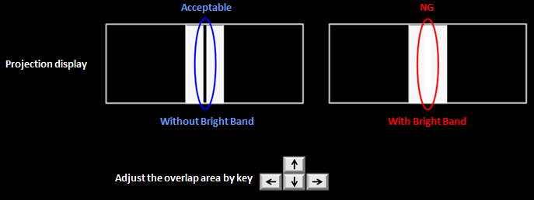

1. **Step 6: Auto Calibration**
2. Click “Auto Calibration” button to finish image blending automatically.





1. **Step 7: Cropping Setting**
2. System will show the pixel of overlap after calibration.
3. Adjust the overlap compensation pixels to graphic card.

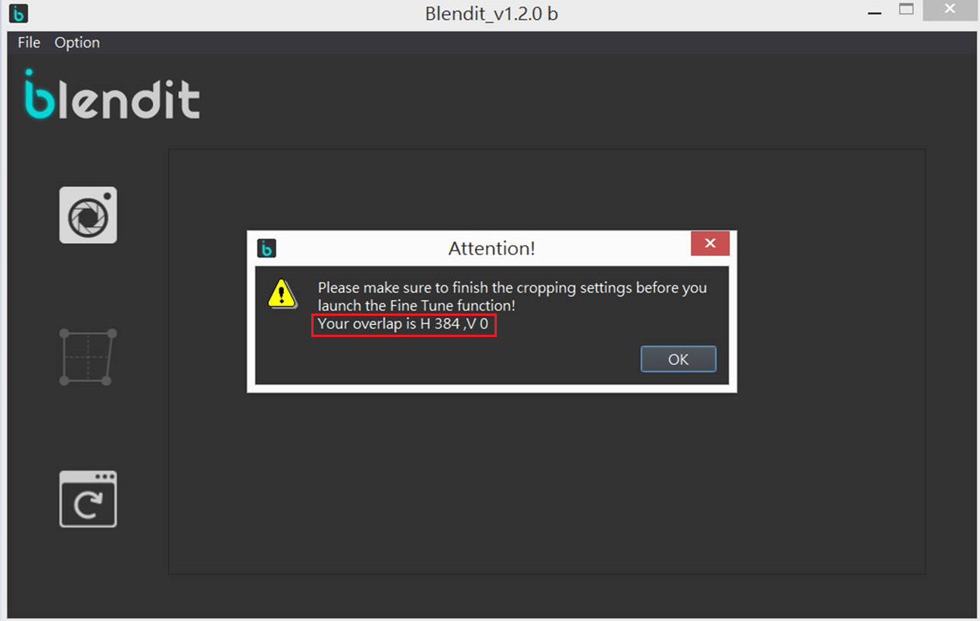

### C. Auto Wizard / Device request – Projector + CS200T

1. **Step 1: Select “File / New Project (Auto)”.**

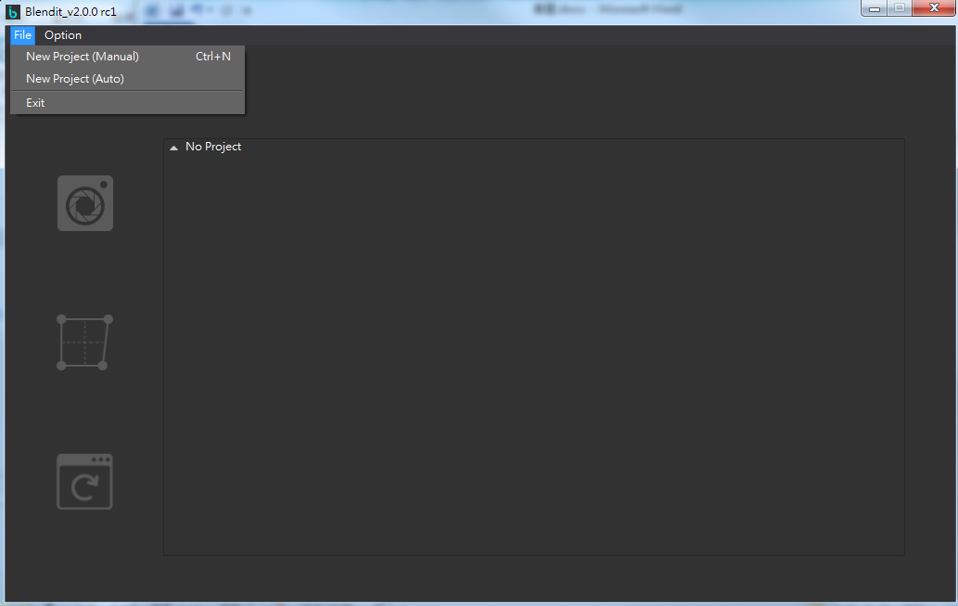

1. **Step 2: Select Device and Blending Automatically**

Select devices according to user’s requirement.

【Note】Click Device Type to correspond the device name on wizard with projectors.

When user clicks projector - Projector being selected shows “Pink” pattern.

When user clicks Box – All projectors show “Yellow” pattern.

【Note】Click Device Name can rename device.



Auto blending process started after clicking “Next”.

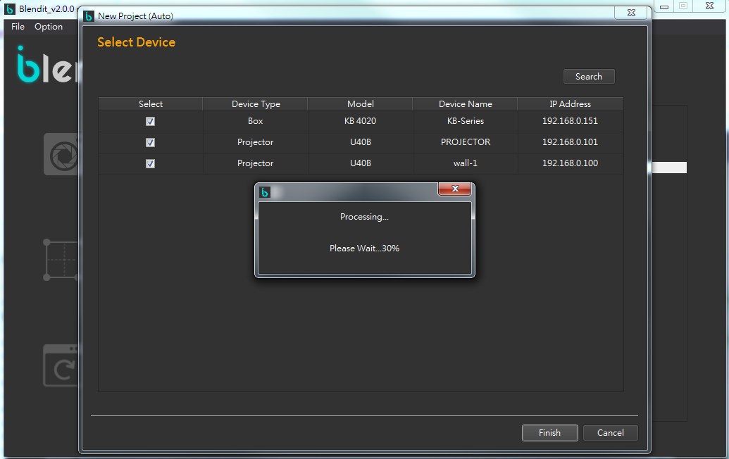

Project information shows on the window display.

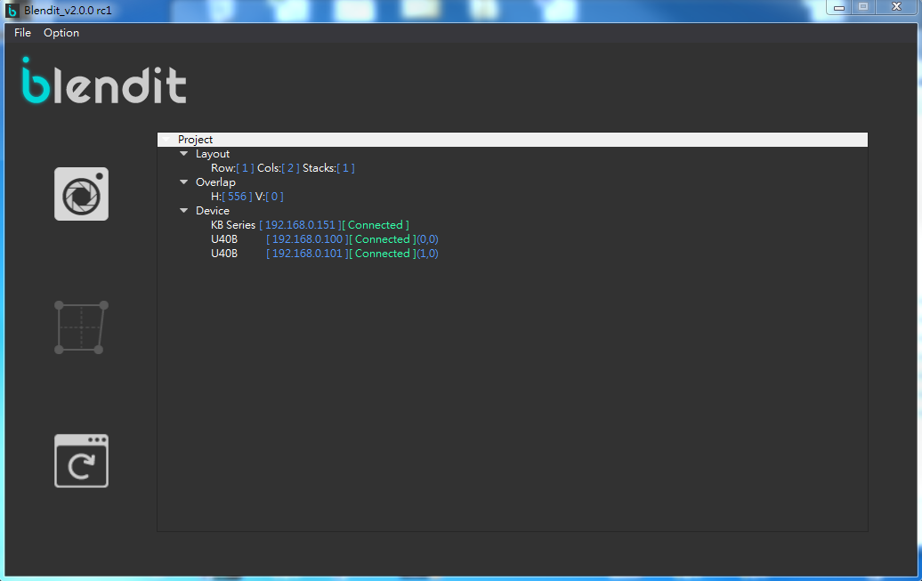

# Fine Tune

1. Before going to next step for boundary adjustment, please connect the control device (PC or Laptop) HDMI out to CS200T HDMI Input and set the extension screen resolution to 1080p@60.
2. Click “Fine Tune” button to adjust the boundary after auto blending procedure.

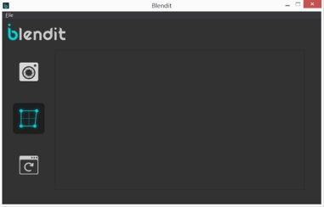

1. Fine Tune Page

In fine tune mode, user can change window focus with mouse pointer between laptop display and projection display.

* Control panel worked when window focus on laptop display. (Grid lines are in purple )
* Control points can be adjusted when focus on projection display. (Grid lines are in white)
* Window focus on laptop display (Grid lines are in purple )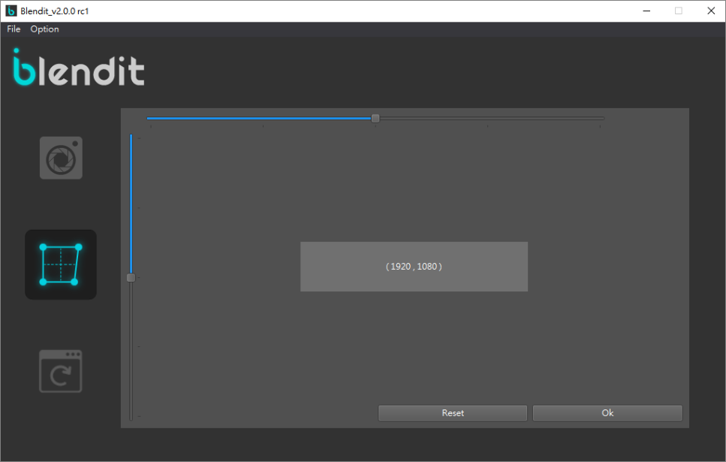

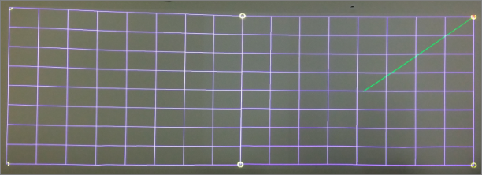

* Window focus on projection display (Grid lines are in white )

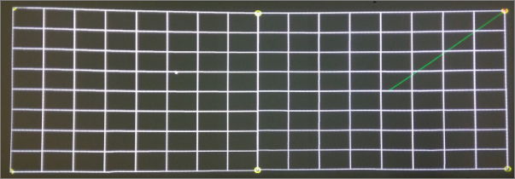

Users can select the control point by mouse or hot key and drag the control point to where the user like to move and click “OK” button on control panel or press hot key “Enter”, and then the screen will change to Cyan solid color and show the warped screen image in 10 seconds.

1. Control Point Adjustment

|  |  |  |
| --- | --- | --- |
| Hot key adjustment | Control panel adjustment | Function |
| 1 | Scroll Bar | Horizontal Control Point Increased |
| 2 | Scroll Bar | Vertical Control Point Increased |
| 3 | Scroll Bar | Horizontal Control Point Decreased |
| 4 | Scroll Bar | Vertical Control Point Decreased |
| R | Reset | Reset Control Point |
| A | Adjust by mouse pointer | Switch to Previous Control Point |
| S | Adjust by mouse pointer | Switch to Next Control Point |
| Up/Down/Left/Right | Adjust by mouse pointer | Shift Control Point |
| Control + Mouse pointer | Adjust by mouse pointer | Adjustment control point rapidly |
| Enter | OK | Fine Tune Finished |

1. Fine tune limitation

Grid line in white: Fine tune adjustment is under the acceptable area of warping. Fine tune will be successful.

Grid line in pink: Fine tune adjustment is over the limitation of warping area. Fine tune will be failed.

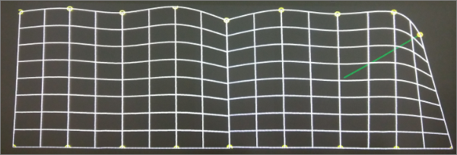

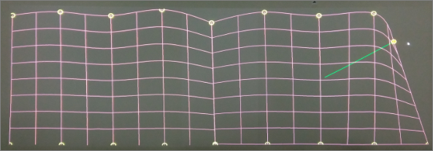

# Advanced Fine Tune

※Note: This function will change EDID. Please set the multiple displays settings to “Extend” when you first entering this function.

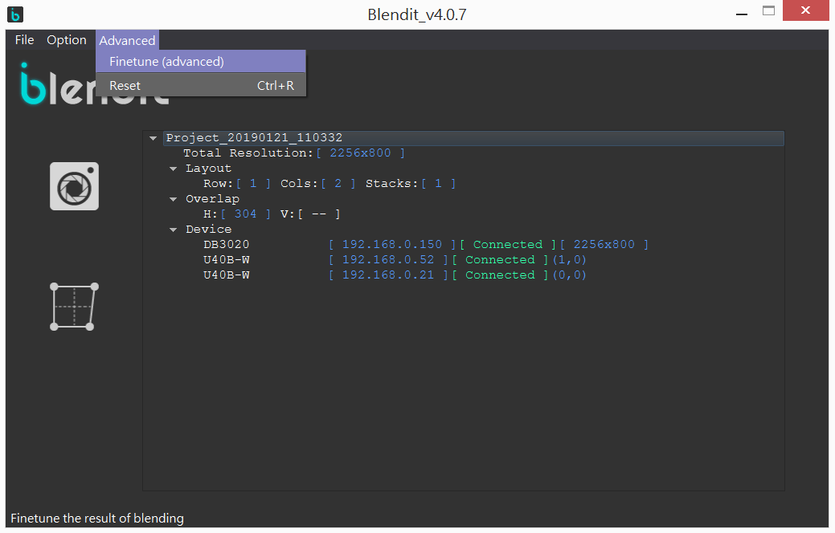

You can edit the mesh with the hotkeys shown in the AP.

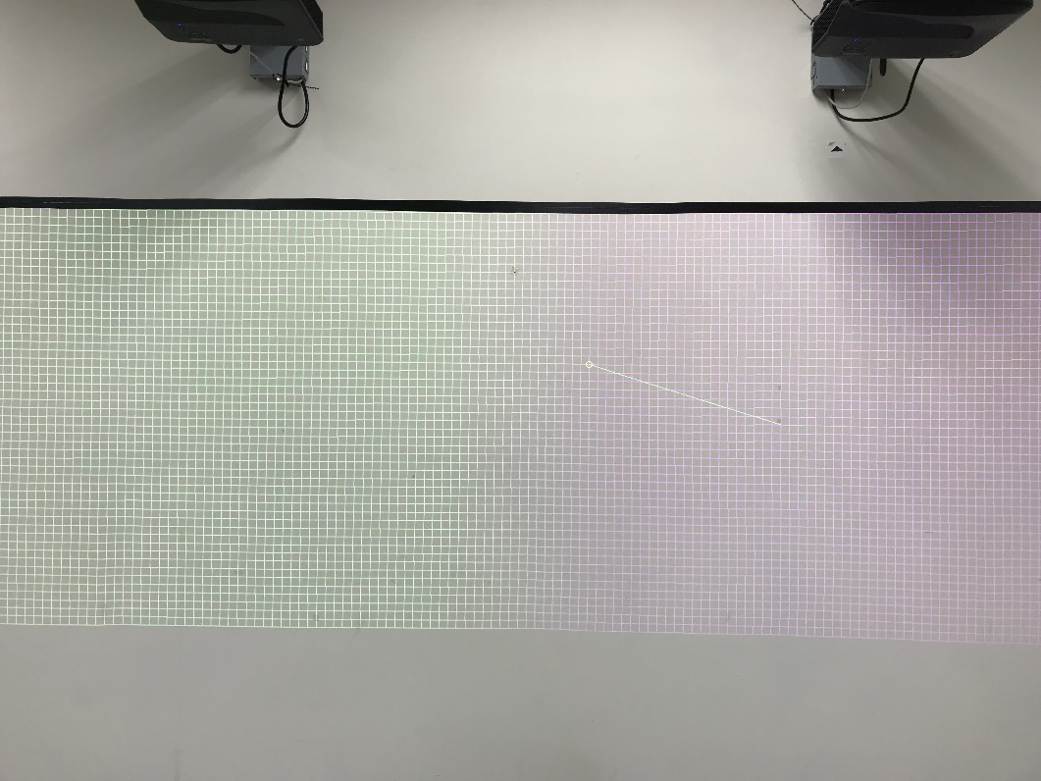

Hotkeys:

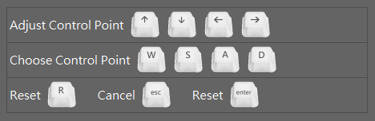

Example:

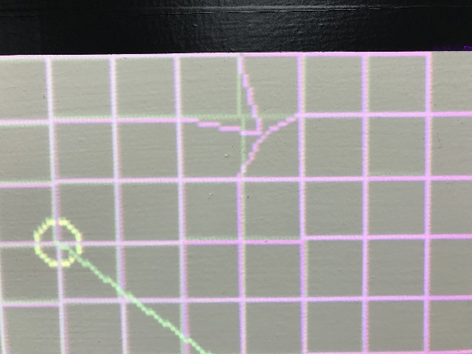 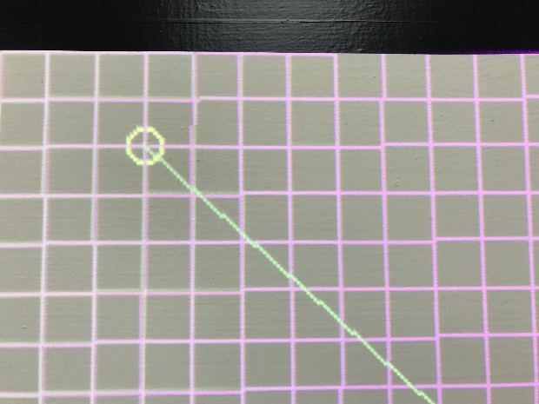

# Black Level Setting

The black level setting of ZH420UST is as below procedure,

After the auto blending procedure is done, user can start the black level process via Advanced > Black Level as below,

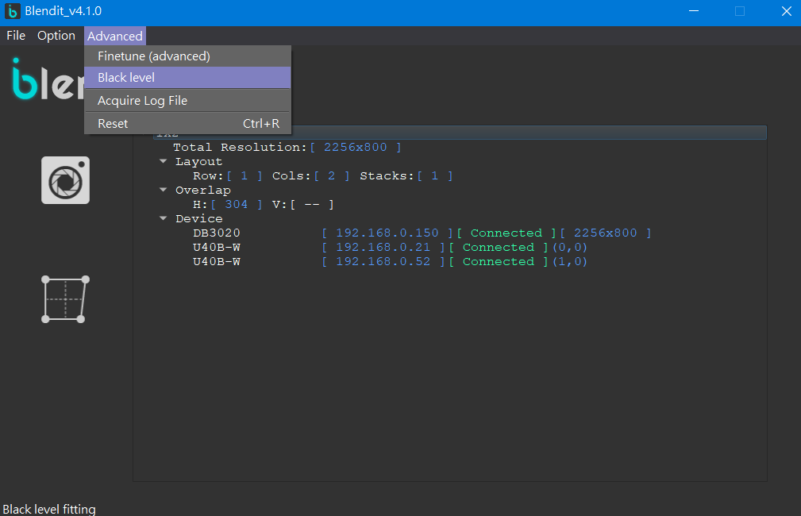

User can control the black level operation by hot key of keyboard, please make reference to below pictures. User can click the Set Area to start the setting of black level active area.

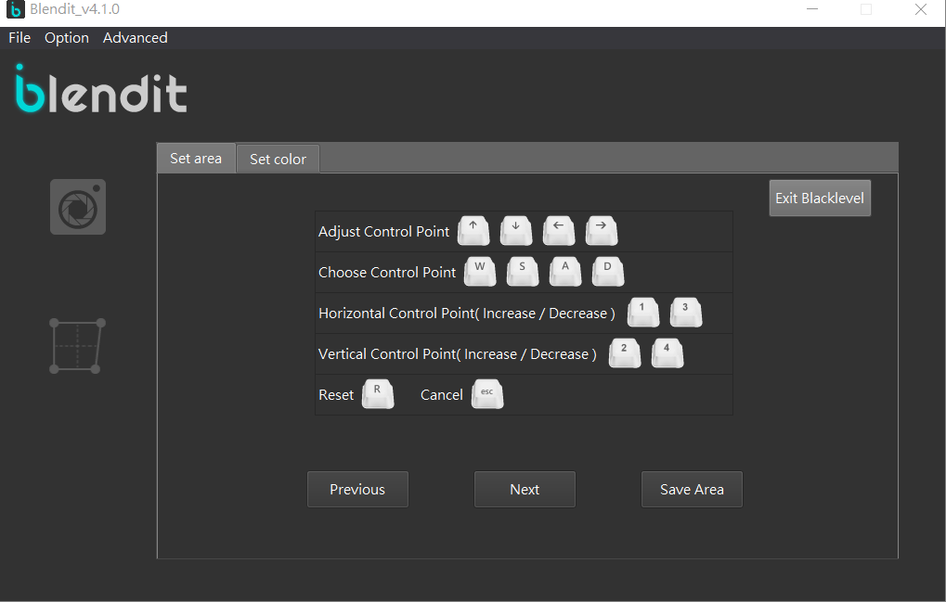

The user can move the black level control point via mouse or keyboard, set the green setting area to match the overlap are. The green area should match the overlap area and the rest of green area would be the active area of black level setting accordingly. Consider the overlap area is not so rectangular shape, user can add the control point for fitting green area to the overlap area easily and accurately. User can make reference to above hot key table. The wrench mark is shown for pointing which projector is active for black level.

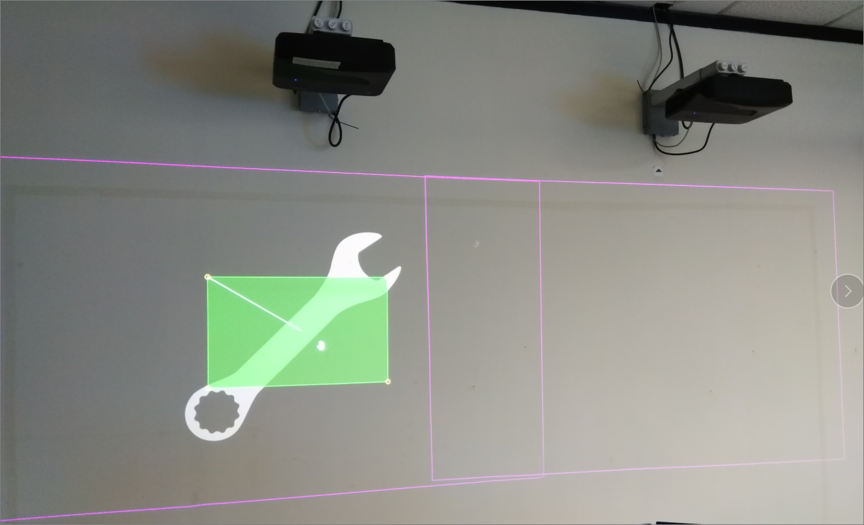

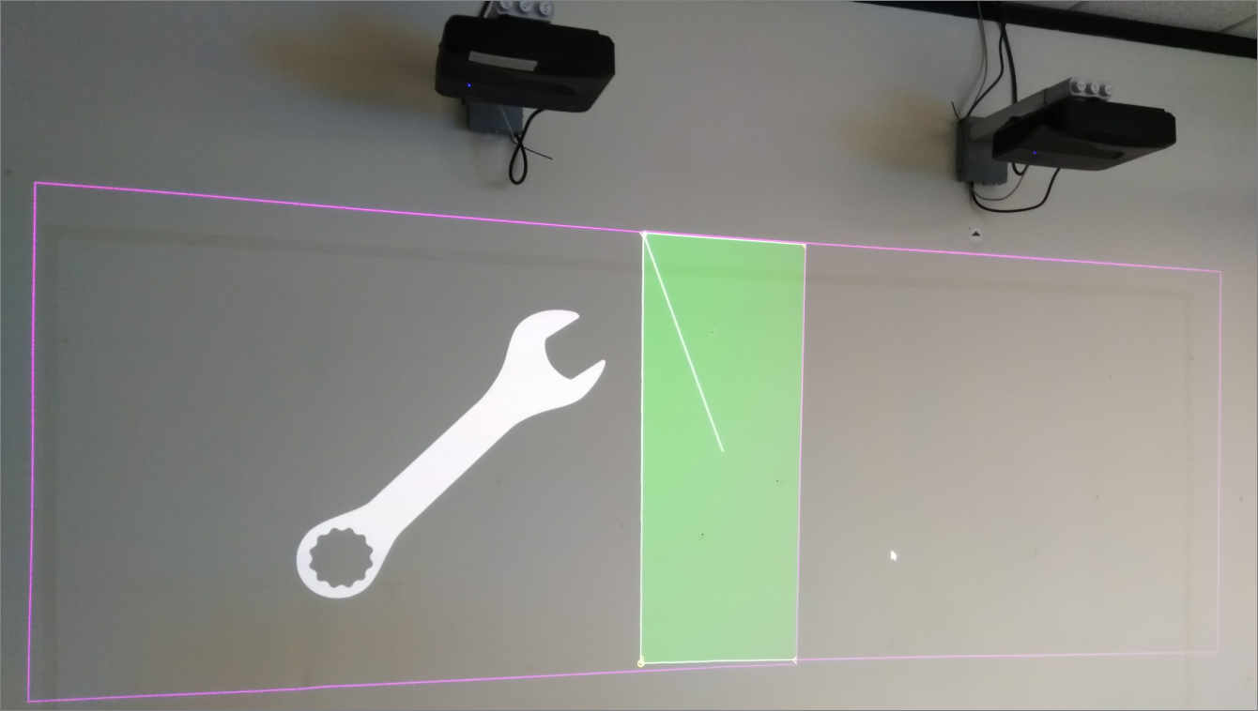

※If the pattern is not shown as above, please set the extension mode to PC or laptop and pick the recommended resolution for extension output image.

After the mark of black level area in first projector is done, then user can go next step to set the second or more projector as the previous procedure to define the black level area.

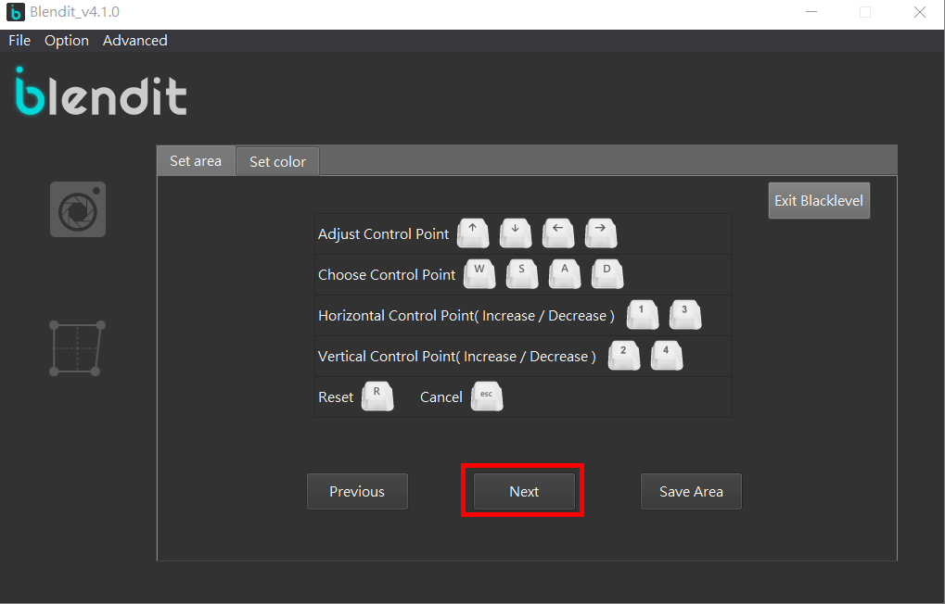

After all the black level area is set, press “Save Area” to save the area setting, then go next procedure of gray level setting to the area user defined.

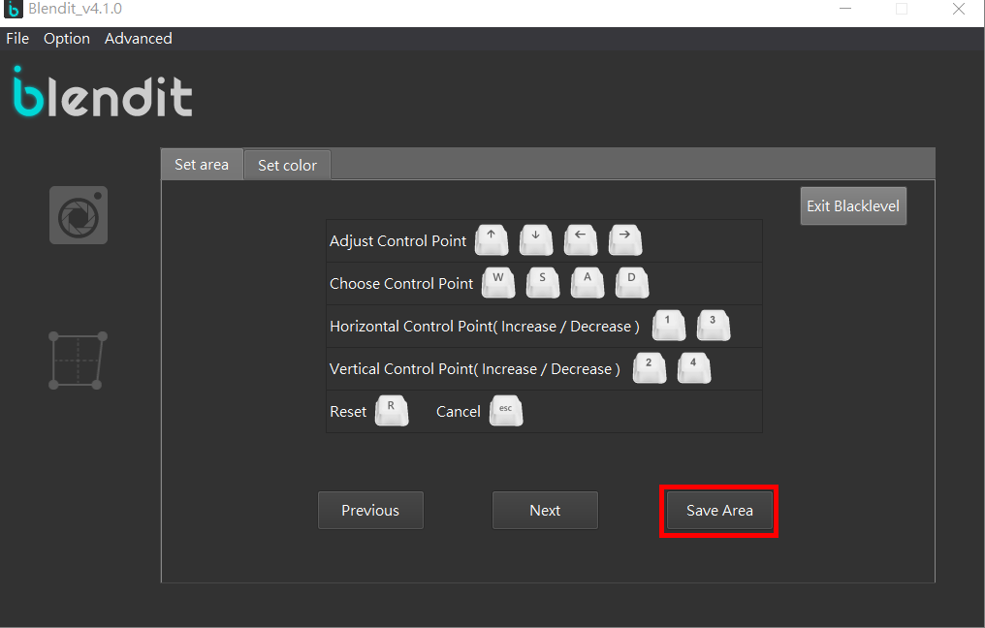

Click Set Color to next step of black level setting. (Recommend to make the ambient as dark as possible.)

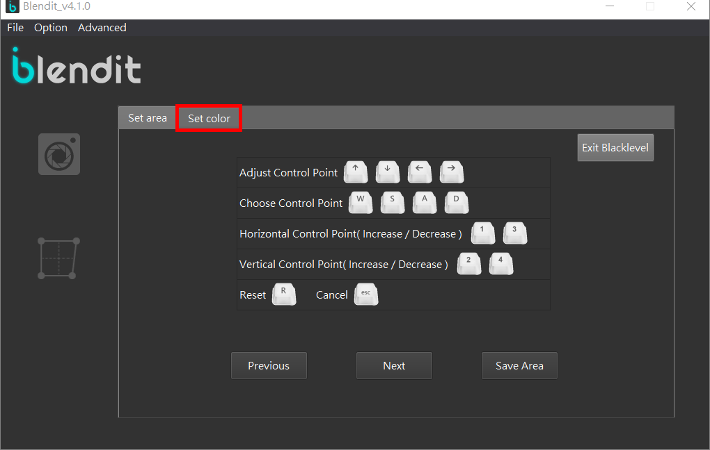

Control the R/G/B value to make the gray level of non-overlap area the same as overlap area.

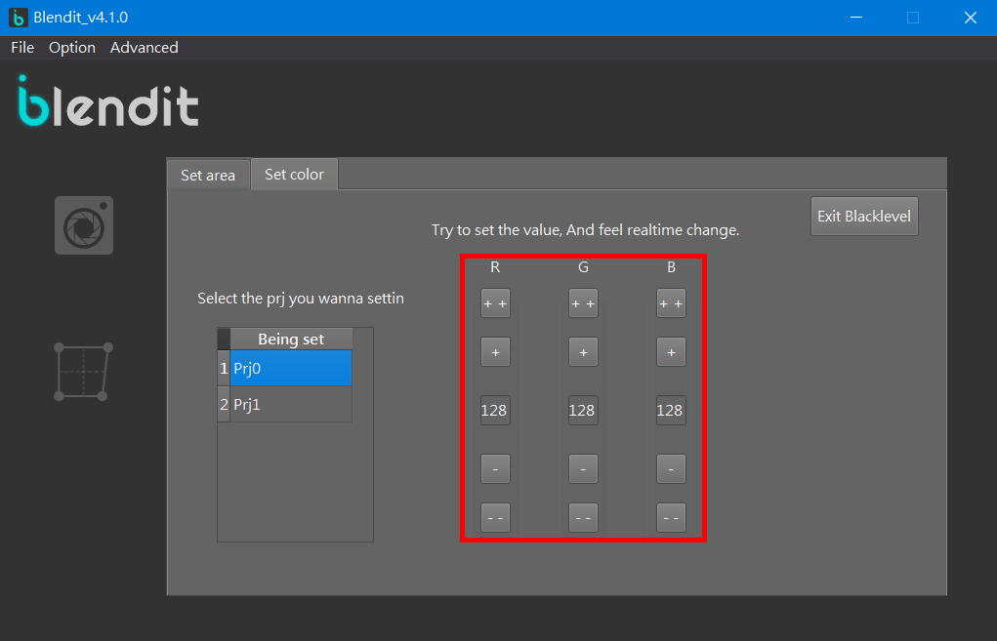

User can set the black level value as above procedure to all projectors and user can pick the projector as below page,

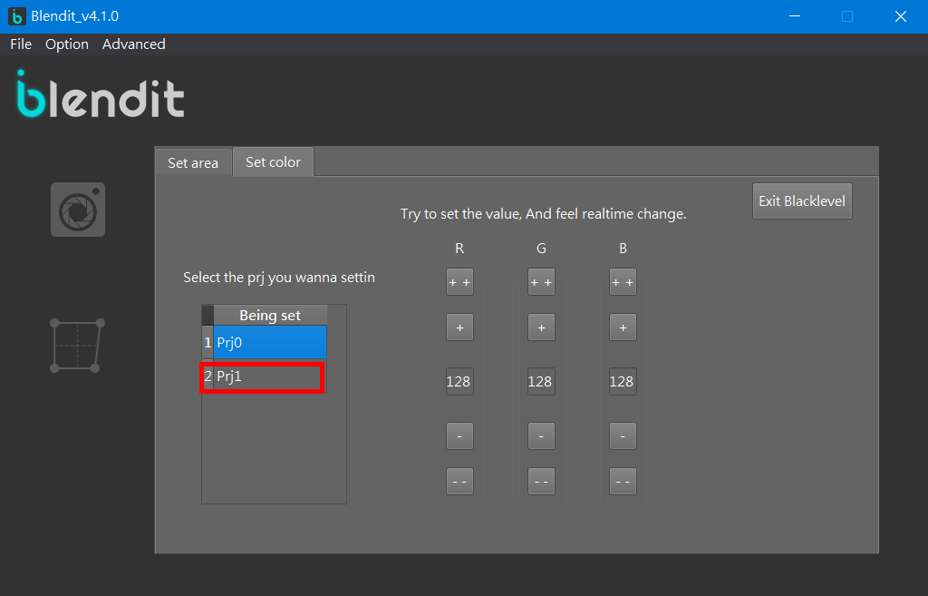

When the value is changed, the value would be adopted immediately, user can observe the gray level change until the gray level is matched with the level of overlap area, then complete the black level setting.

